St. Francis Institute of Technology, Mumbai-400 103

**Department Of Information Technology**

A.Y. 2024-2025

Class: TE-ITA/B, Semester: V

Subject: **DevOps Lab**

**Experiment – 8: To setup and run Selenium tests in Jenkins using Maven.**

1. **Aim:** To setup and run Selenium tests in Jenkins using Maven
2. **Objectives:** Aim of this experiment is that, the students will learn:

* Selenium and how to automate your test cases for testing web elements
* Introduction to X-Path, TestNG and integrate Selenium with Jenkins and Maven.

1. **Outcomes:** After study of this experiment, the students will learn following:

* Introduction to Selenium
* Installing Selenium
* Creating Test Cases in Selenium WebDriver
* Run Selenium Tests in Jenkins Using Maven

1. **Prerequisite:** Knowledge of Software Engineering concept of testing and test cases.
2. **Requirements:** Jenkins,JDK, Eclipse IDE, Firefox browser,Personal Computer, Windows operating system, Internet Connection, Microsoft Word.
3. **Pre-Experiment Exercise:**

**Brief Theory:** Refer shared material

1. **Laboratory Exercise**
   * + 1. **Procedure:**

**a. Answer the following:**

* Explain Selenium suite?
* What are the limitations of Selenium IDE?

**b**. **Execute following (Refer the shared material) and attach screenshots:**

* Create and run a test case on Chrome/Firefox browser with selenium IDE addon
* Create a Maven Project in Jenkins and run selenium tests using selenium Grid

1. **Post-Experiments Exercise**
2. **Extended Theory:**

Nil

1. **Questions:**

* What are Locators? Explain its types.
* What is the benefit of using Selenium Grid with Jenkins?

1. **Conclusion:**

* Write what was performed in the experiment.
* Write the significance of the topic studied in the experiment.

1. **References:**

<https://jenkins.io/doc/>

<https://www.slideshare.net/abediaz/introduction-to-jenkins>

<https://q-automations.com/2019/09/26/selenium-grid-with-jenkins/>

Procedure:

a. Answer the following:

1. Explain Selenium suite?
2. What are the limitations of Selenium IDE?
3. ANSWERRRRRRRRRRRRRRRRRRRRRRRRRRRRRRRR

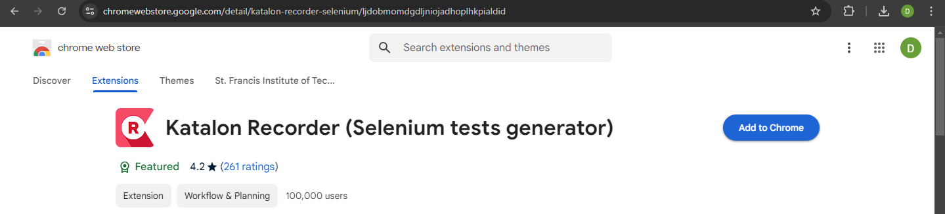

get katalon recorder screenshots

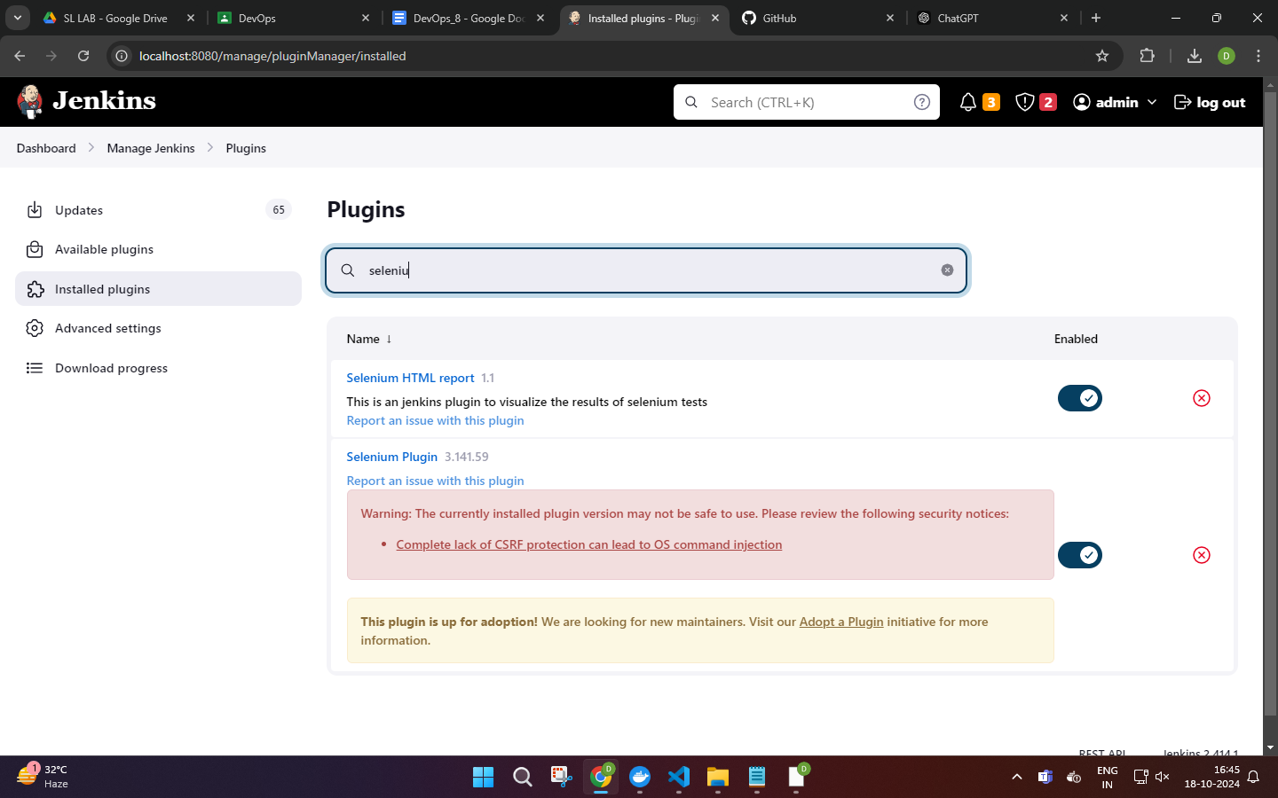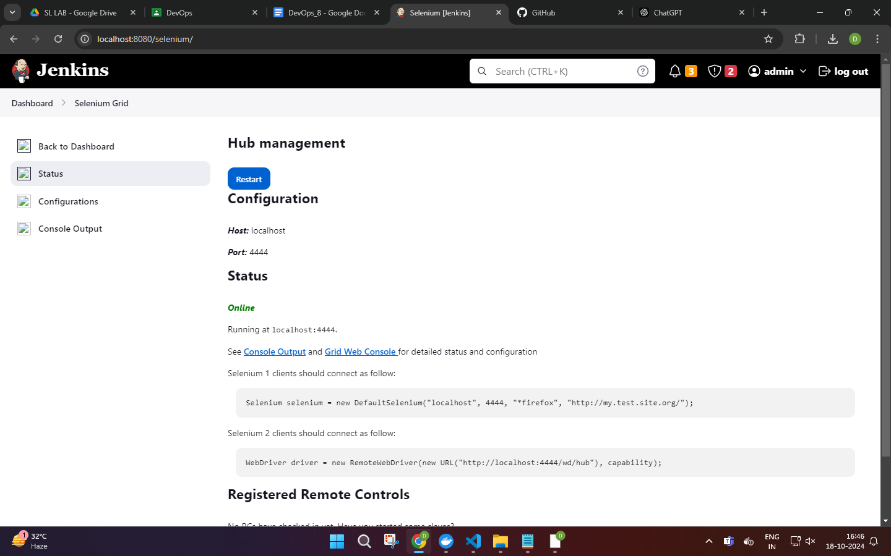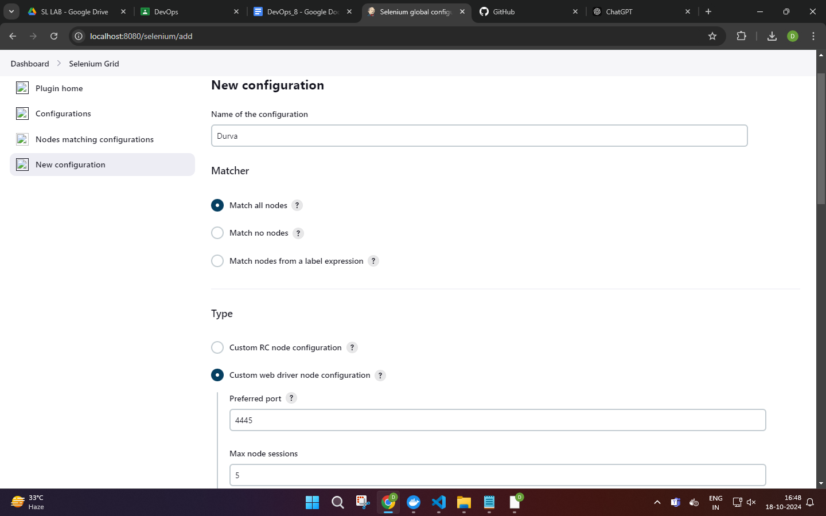



https://github.com/rajnervatla/SleniumProjectPractice